Install SVN repositpory:

https://LT040713.cts.com/svn/MAster_Repo

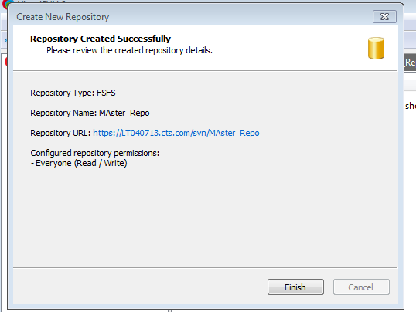

GIT HUB installation from GIThub.org link

<https://github.com/nikisudha/devops_training.git>

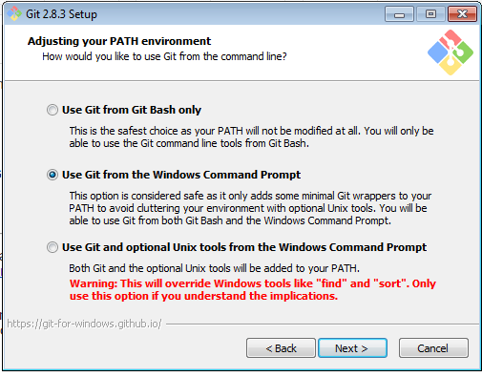

Bash and command for Linux

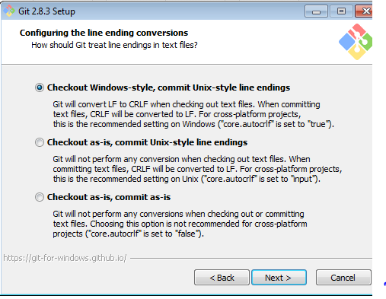

After installation -> all programs ->

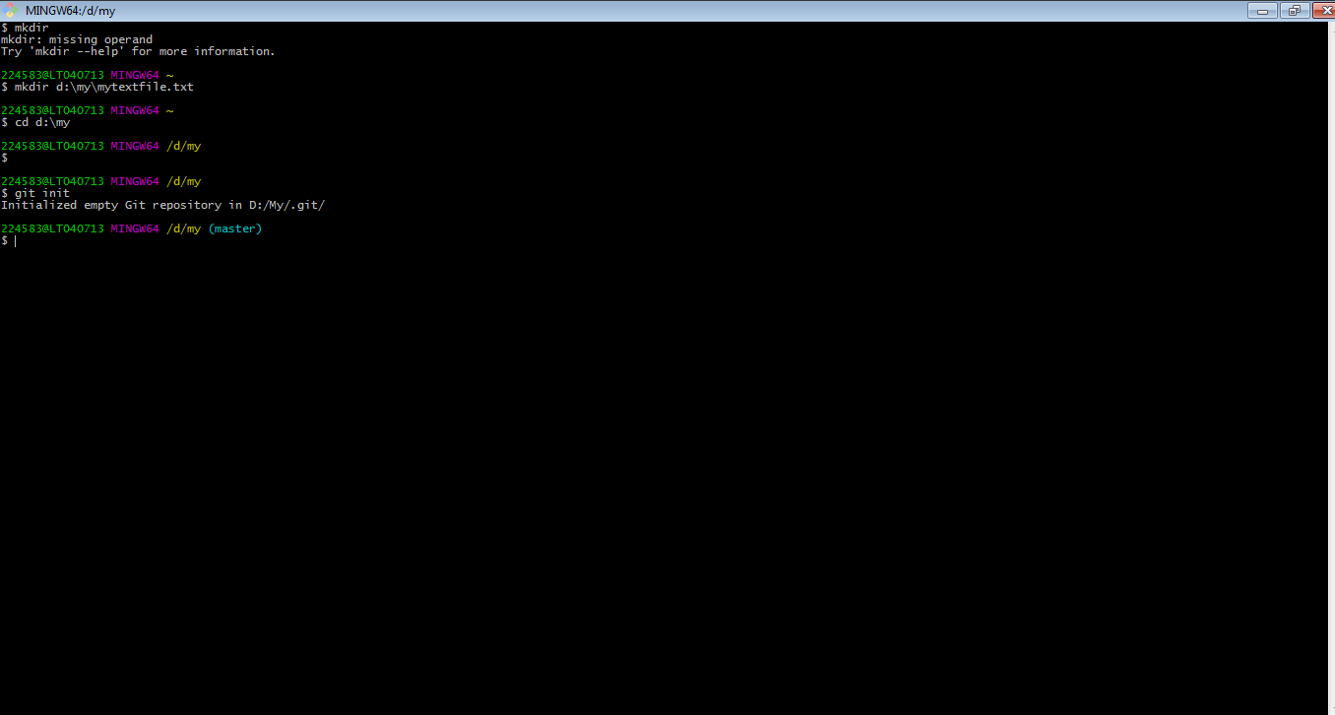

Create empty repo is staging folder (.git)

